Aquatint
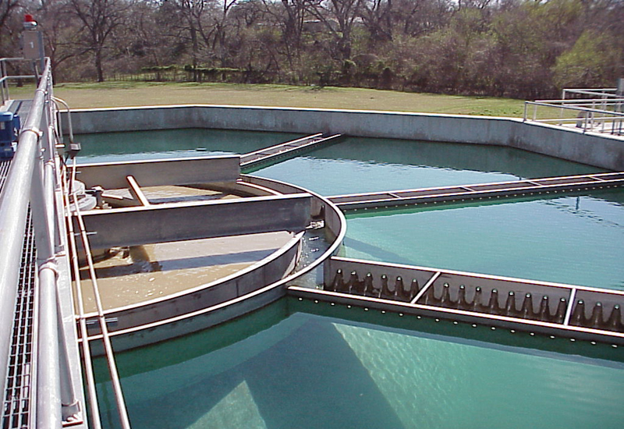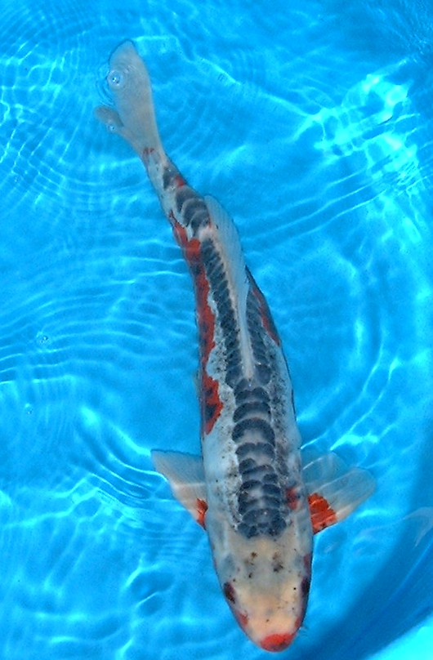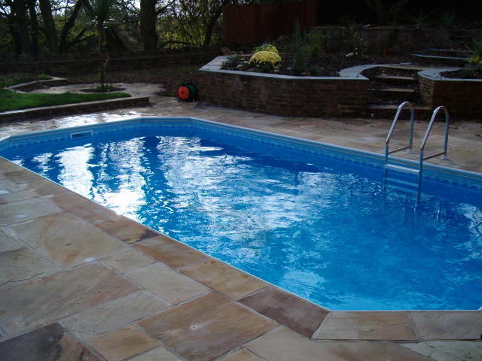

Aquatint has been used in many different applications

Swimming pools :
Giving long lasting safe finish

Fish ponds :
used in many fish ponds without any issues

Sewage works:
Used in many different areas of sewage works.

Rain water collection:
For irrigation of garden centre plants

ACE COATINGS SOUTH LTD
UNIT 11 SHEDDINGDEAN IND EST, BURGESSHILL,RH15 8QY
TEL 01444 870087

